**SQL Job PreparationAssignment 5**

**Note: -** For below all queries I used **Live SQL** by oracle as they provide inbuilt **HR Schema** for practice purpose and in my local system, I don’t have HR Schema.

1. Write a query to DISPLAY THE "DEPTNO" AND "SUM OF SALARY" FOR EACH DEPTNO.

Sol: -

SELECT DEPARTMENT_ID, SUM(SALARY)

FROM HR.EMPLOYEES

GROUP BY DEPARTMENT_ID;

2. Define INNER JOIN and OUTER JOIN, then use a query to demonstrate each.

Sol: -

INNER JOIN: - It will select only matching records form the both tables.

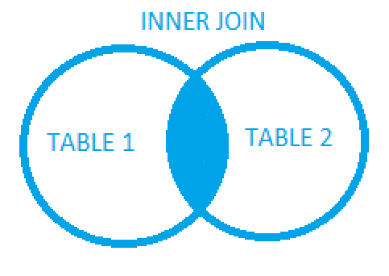

SELECT T1.LAST_NAME, T1.DEPARTMENT_ID, T2.LOCATION_ID

FROM HR.EMPLOYEES T1

INNER JOIN HR.DEPARTMENTS T2

ON T1.DEPARTMENT_ID = T2.DEPARTMENT_ID

ORDER BY T1.EMPLOYEE_ID;

OUTER JOIN: - Full Outer Join will return all matching records from both tables whether the other table matches or not.

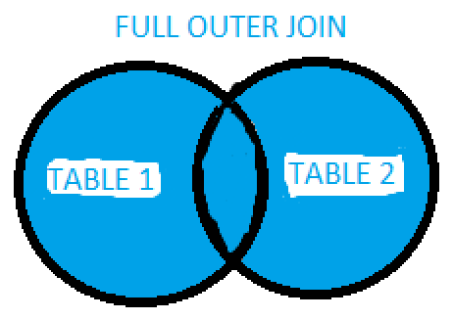

SELECT T1.LAST_NAME, T1.DEPARTMENT_ID, T2.LOCATION_ID

FROM HR.EMPLOYEES T1

FULL OUTER JOIN HR.DEPARTMENTS T2

ON T1.DEPARTMENT_ID = T2.DEPARTMENT_ID

ORDER BY T1.EMPLOYEE_ID;

3. WHAT DO YOU MEAN BY VIRTUAL TABLES? as well as how to make one.

Sol: - In SQL, view is a virtual table. It contains rows and columns just like real table.

We make these views because some queries are complex and we might need to run a bunch of queries multiple times. In that scene we take help of views as it won’t take any physical memory in our system.

I used HR Schema and make new column which is combination of **commission + salary** and created view for it.

CREATE OR REPLACE VIEW NEW_COMM AS

SELECT EMPLOYEE_ID, SALARY,

SALARY+NVL(COMMISSION_PCT,0) as NEW_COMMISSION

FROM HR.EMPLOYEES ;

4. Rewrite the below query using Subqueries. SELECT * FROM EMP WHERE SAL=MAX(SAL);

Sol: -

SELECT * FROM HR.EMPLOYEES

WHERE SALARY=(

SELECT MAX(SALARY)

FROM HR.EMPLOYEES

);

Result: -

|  |  |  |  |  |  |  |  |  |  |  |
| --- | --- | --- | --- | --- | --- | --- | --- | --- | --- | --- |
| **EMPLOYEE_ID** | **FIRST_NAME** | **LAST_NAME** | **EMAIL** | **PHONE_NUMBER** | **HIRE_DATE** | **JOB_ID** | **SALARY** | **COMMISSION_PCT** | **MANAGER_ID** | **DEPARTMENT_ID** |
| 100 | Steven | King | SKING | 515.123.4567 | 17-JUN-03 | AD_PRES | 24000 | - | - | 90 |

5. Table:

This is demo table

EMP_ID SAL

101 5000

102 5600

Sol: - As there is no complete question provided except the table I have wrote queries for creating and inserting the records.

CREATE TABLE DEMO (EMP_ID INT, SAL INT);

INSERT INTO DEMO VALUES (101,5000);

INSERT INTO DEMO VALUES (102,5600);